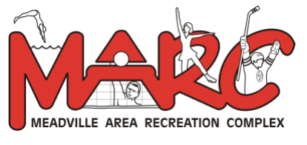

FALL/WINTER 2019
Please  ()  Session  registering for | # of  Sessions | Lessons Dates | Registration  Fee
 | 6 | September 10, 12, 17, 19, 24, 26 | $35 | 6-8pm
 | 4 | October 5, 12, 19, and 26 | $25 | 11-1pm
 | 4 | November 2, 9, 16, and 23 | $25 | 11-1pm
 | 4 | January 4, 11, 18, and 25 | $25 | 11-1pm
 | 4 | February 1, 8, 15, and 22 | $25 | 11-1pm
 | 4 | March 7, 14, 21, and 28 | $25 | 11-1pm

LEARN TO SWIM PROGRAM
6 Months and older ONLY
All Swimmers must pre-register, can pre pay or pay that day.
One application must be filled out per child per session.

THE MARC RESERVES THE RIGHT TO CANCEL AND/OR CHANGE ANY DATES, PRICES, OR TIMES OF CLASSES, PROGRAMS, & PUBLIC SESSIONS. WE DO NOT ISSUE REFUNDS, TRANSFER PACKAGES, OR EXCHANGE PACKAGES

GROUP TIMES
September

6:00 – 6:45pm Mommy and me, Level 1, and Level 2
6:50 – 7:35pm Level 3 and 4

October - March
I hereby give my consent for my child or self to participate in the above program sponsored by the MARC. I furthermore release the Meadville Area Recreation Authority, Staff and all concerned from all liability for any injuries I may incur resulting from participation in this Program.
Parent Signature:
Child Name
Birth Date |  |  |  |  | Age:
Phone |  |  |  |  | Cell:
E-mail
Street
City, State |  |  |  |  | Zip:
Township: (circle) |  | City of Meadville, West Mead, Vernon |  |  | Other:______
Your Name:
For Office Only:
 | Staff:_________________ Date: __________________
 | TOTAL COST: _________ CASH CHARGE CHECK#: ___________________________________________________
Cost for this Swim Lesson is ______________________

11:00 – 11:45am Mommy and me, Level 1, and Level 2
11:50am – 12:35pm Level 3 and 4

Level 1: Intro to Swimming

